# Eastern Goldfields College Year 12 2019

# Mathematical Methods Investigation 2

Out of Class Section

**PROBABILITY/STATS**

Name:

**DATE**: Handout: Thursday June 13th 2019

Due: Tuesday June 18th 2019

Test day: Thursday June 20th 2019

* *The Out of Class Investigation is designed for you to learn the essentials needed for the In-Class validation.*
* *This is the “Take Home” part of the Investigation. It does not count towards your mark for this investigation.*
* *You will need your Casio Classpad.*

This investigation covers three main ideas:

* The Standard Deviation/Variance of a distribution.
* The concept of Binomial Probability
* 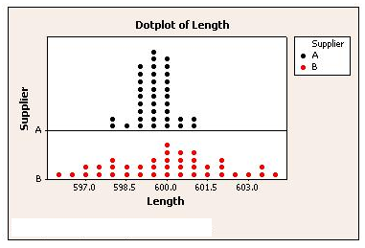Mathematical Expectation.

**Part One: Standard Deviation/Variance**

The variance and standard deviation are measures of how widely

spread out or dispersed a distribution is.

Standard deviation = 

Important note:

1. Consider the dot plot to the right comparing the lengths of

metal piping from two suppliers. The suppliers are paid to

produce 600 mm length pipes for a company.

Without doing any calculations, explain which supplier has the highest variance and standard deviation of the length of pipe provided. Give reasons for your answer.

1. The definition of variance is the average of the square deviations from the mean. i.e .

You will need to calculate the deviation from the mean of each score, square them, add them and divide by the number of scores. Use this table to calculate the variance and standard deviation of these scores by a netball side in the first quarter. Check your answer by using your calculator.

Mean of data  = …………….

Calculations:

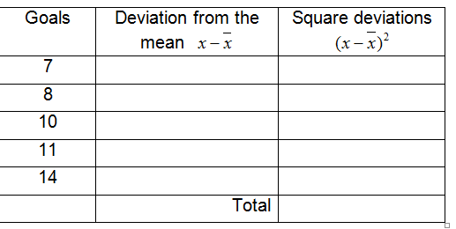

Variance;

Standard deviation (2 dp)

1. 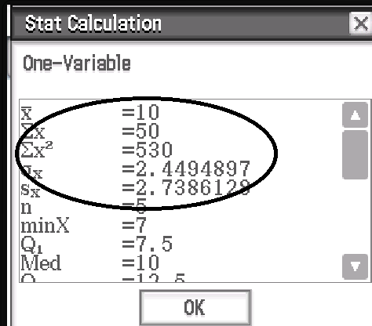Here is the result of using the

Statistics Aplet on your Casio.

Explain in words what is represented by

1. 
2. 
3. 

Please note that the term sx represents the standard deviation

of a sample and is calculated slightly differently than .

1. Use the table method to practice calculating the variance and standard deviation of the number of residents in each house in a street. . Check your answer using your calculator afterwards.

|  |  |  |
| --- | --- | --- |
| Residents | Deviation from mean | Square deviations |
|  |  |  |
|  |  |  |
|  |  |  |
|  |  |  |
|  |  |  |
|  |  |  |
|  | Total |  |

Calculations;

Variance;

Standard deviation (2 d.p);

1. An alternative rule for variance is . In words this means the mean of the square scores taken away from the mean squared. Repeat the calculations from the table above using this rule to verify the answer is the same.

|  |  |
| --- | --- |
| Residents | Square of the scores |
|  |  |
|  |  |
|  |  |
|  |  |
|  |  |
|  |  |
| Total |  |

Calcualtions;

Is it the same? ………………..

Use your calculator for these questions:

1. To get an A grade a student must get at least 1.5 standard deviations above the mean. Looking at the final scores below determine which students will get an A grade.

|  |  |  |  |  |  |  |  |  |  |  |  |
| --- | --- | --- | --- | --- | --- | --- | --- | --- | --- | --- | --- |
| Student | A | B | C | D | E | F | G | H | I | J | K |
| Mark | 51 | 53 | 56 | 57 | 60 | 63 | 70 | 78 | 86 | 63 | 89 |

1. A wealthy overseas investor is looking to set up a vineyard somewhere in the South-West. The investor has 3 potential sites to choose from and to help her choose she looks at the rainfall for each site for the last 10 years. The rainfall in millimeters rounded to the nearest 10mm over the last 10 years is shown.

|  |  |
| --- | --- |
| Site A | 480 730 810 750 810 870 590 630 890 800 |
| Site B | 790 710 720 720 740 720 690 750 740 740 |
| Site C | 660 700 620 710 630 640 720 1050 970 590 |

C:\Program Files\Microsoft Office\Clipart\standard\stddir3\fd01109_.wmf

1. Plot the dot frequency diagram for each site.







|  |  |  |
| --- | --- | --- |
|  | Mean | Standard Deviation |
| Site A |  |  |
| Site B |  |  |
| Site C |  |  |

b) Calculate the following statistics for each Site

1. Explain what the standard deviation of each site

indicates for the wine investor.

d) Which site would you choose if you were the wine investor? Justify your answer.

1. What have you learned about standard deviation/variance?

**Part Two: Bernoulli Trials (the Binomial Probability Distribution)**

Consider this scenario: A basketball player has a 75% (¾) success rate for foul shooting. He is fouled outside the 3 point line (giving him 3 free shots) with 0.1 seconds to go and his side is 1 point behind.

What are his team’s chances of winning after he completes his 3 shots?

Consider this diagram and accompanying table;

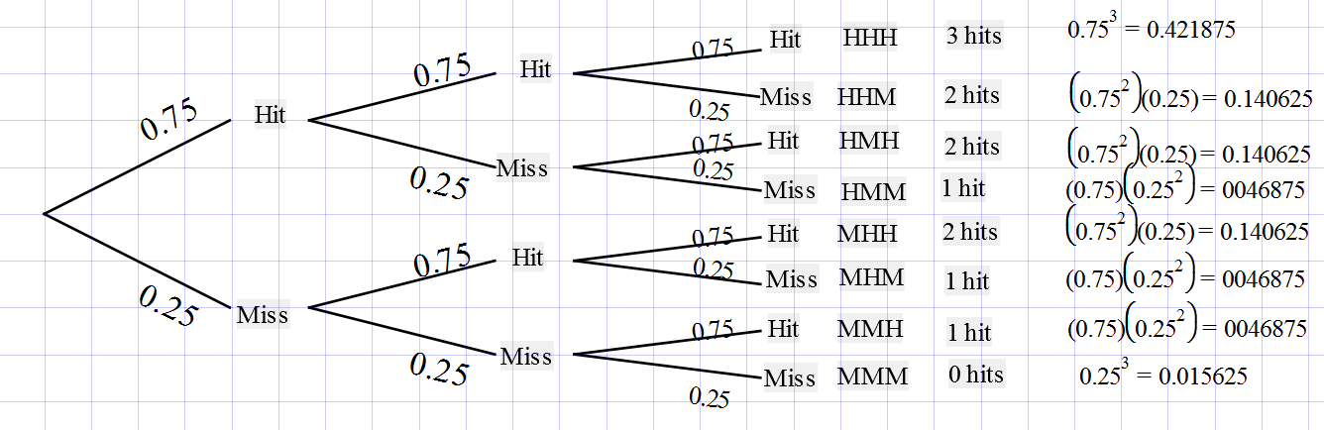

|  |  |  |
| --- | --- | --- |
| x | Calculations | P(X=x) |
| 3 | 0.753 | 0.421875 = 42.2% |
| 2 | 3 x 0.752 x 0.25 | 0.421875 = 42.2% |
| 1 | 3 x 0.75 x 0.252 | 0.140625 = 14.1% |
| 0 | 0.253 | 0.015625 = 1.6% |

1. Use this information above to answer the following.

a) What is the chance of getting all 3 free shots? ……………

b) What is the chance of getting 1 out of 3 shots in? …………………

c) What is the chance that the player’s team won after he completes his 3 free shots? ………………….

d) Explain why the calculation for 2 shots in was 3 x 0.752 x 0.25 = 0.421875.

e) Imagine another player, with a 60% free shot success rate, was fouled instead. Recalculate the probabilities in the table below.

|  |  |  |
| --- | --- | --- |
| x | Calculations | P(X=x) |
| 3 |  |  |
| 2 |  |  |
| 1 |  |  |
| 0 |  |  |

f) What is now the chance the team wins? Was it reduced by much?

1. You calculated the theoretical chances of the team winning in the previous questions for those two players but the world is random and the real world won’t always follow the theory exactly. In this question we will run 100 trials, using your calculator to see how closely the experiment can match the theory.

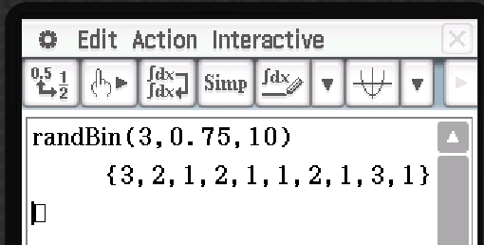

1. Place the expression randbin(3,0.75,10) on your calculator and press

execute. (randbin can be found in the catalogue of your calculator).

Explain what each of the numbers in randbin(3,0.75,10) represents.

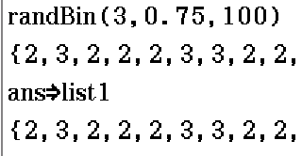

b) Now we will run the trial 100 times, not 10 times!

* 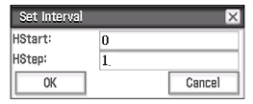type in randbin(3,0.75,100)
* save this list into List 1 (see to the right).
* Go to statistics and check to see if your numbers are in List1.
* Draw a histogram of your data by using SetGraph.
* Make your graph start at 0 and step up in ones.
* Use the trace button to move across your graph and

check the total for each column.

*For extra help at home go the Classpad Help Series on the internet, and then go to Australian Senior Courses M34 and Random Sample from Binomial Distribution.*

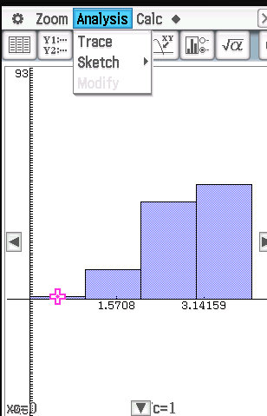

c) Place your results in the table below and calculate the probabilities.

Experimental results on calculator.

|  |  |  |  |  |
| --- | --- | --- | --- | --- |
| x | 0 | 1 | 2 | 3 |
| Frequency |  |  |  |  |
| Relative frequency |  |  |  |  |

d) Place experimental data and theoretical data from previous question

into the following tables and comment on how similar or different the results are.

|  |  |  |  |  |
| --- | --- | --- | --- | --- |
| x | 0 | 1 | 2 | 3 |
| Theoretical probability |  |  |  |  |
| Relative frequency |  |  |  |  |

**A Bernoulli sequence/ the binomial probability distribution occur under the following conditions.**

* **in each trial there are two outcomes only, usually designated success or failure.**
* **the probability of success and failure from one trial to another stays the same**
* **The trials are independent of each other, what happens on one doesn’t affect the chances of the other.**

**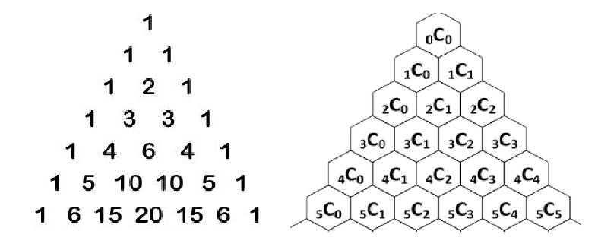Shortcut for theoretical calculation:**

The formula for any individual probability calculated from

the Binomial probability distribution uses the combination

rule but Pascal’s triangle can be used for small values.

The rule for Binomial probability:

if X is a binomial random variable then the probability of

x successes in n trials is P(X = x) = .

For instance in question 9, n = 3 (shots), p = 0.75, q = 0.25 and x was the number of Hits,

so P(2 hits) = = 0.421875.

1. Consider this situation: In June in Pemberton there is a 65% chance of rain on any particular day.

A family is going to spend a 4 day holiday in Pemberton in the July holidays.

1. Calculate the probability distribution for the number of rainy days (R) out of the 4.

|  |  |  |
| --- | --- | --- |
| r | Calculations | P(R=r) |
| 0 |  |  |
| 1 |  |  |
| 2 |  |  |
| 3 |  |  |
| 4 |  |  |

1. Model this situation on the calculator for the family and record the experimental relative frequency distribution below.

|  |  |  |  |  |  |
| --- | --- | --- | --- | --- | --- |
| x | 0 | 1 | 2 | 3 | 4 |
| Frequency |  |  |  |  |  |
| Relative frequency |  |  |  |  |  |

1. Compare the theoretical to the experimental results below.

|  |  |  |  |  |  |
| --- | --- | --- | --- | --- | --- |
| x | 0 | 1 | 2 | 3 | 4 |
| Theory |  |  |  |  |  |
| Relative frequency |  |  |  |  |  |

1. The family will be happy if it only rains on 2 days or less.

Give the theoretical probability and experimental probability the family will be happy.

1. Records show that 42% of young drivers pass their driving test on the first go. From a class of 9 students calculate the probability that more than half will pass on their first driving test.

**Part Three: Mathematical Expectation**

The mathematical expectation of a probability distribution is the expected result in the long run. The formal definition is

E(x) =  which means the sum of the products of the probability of an event and the result for each event.

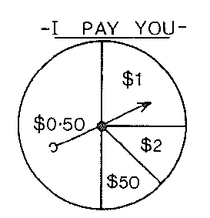

For example: Would it be worth playing this game with a spinner if each spin costs me $10?

Note: prize of $1 = 10 – 1 loss of $9

Answer:

|  |  |  |  |  |  |
| --- | --- | --- | --- | --- | --- |
|  | A | B | C | D |  |
| x | -$9.50 | -$9 | -$8 | +$40 |  |
| p(x) | 0.5 | 0.25 | 0.125 | 0.125 | Total |
| x.P(x) | -$4.75 | -$2.25 | -$1 | $5 | ***-$3*** |

Answer: -$9.50 x 0.5 + -$9 x 0.25 + -$8 x 0.125 + $40 x 0.125 = -$3

I would expect to lose $3 per game, therefore no, it would not be worth playing this game.

1. An amateur sports club decides to play a gambling game which costs $5 to play.

You throw a die and if one comes up you win $1, if two comes up you win $2, three appears therefore $3, four appears you win $4, five appears the player wins $6 and if a six comes up you win $12.

How much would the club expect to win each game? Show working.

|  |  |  |  |  |  |  |  |
| --- | --- | --- | --- | --- | --- | --- | --- |
| Throw | 1 | 2 | 3 | 4 | 5 | 6 |  |
| x | -$4 | -$3 | -$2 | -$1 |  |  |  |
| P(x) |  |  |  |  |  |  | Total |
| x.P(x) |  |  |  |  |  |  |  |

1. 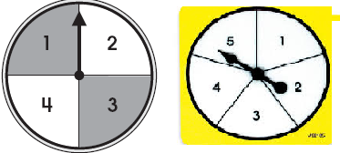***Counter Products***.

This game is played these spinners.

The numbers are multiplied.

1. Show all outcomes in the table below.

|  |  |  |  |  |  |
| --- | --- | --- | --- | --- | --- |
|  | **1** | **2** | **3** | **4** | **5**  ***Counter products***  ***You pay $2 to play.***  ***You spin two spinners and multiply the results.***  ***If a product of 16 comes up your payout is $30***  ***If you get a product of 2 or 9 your payout is $2.*** |
| **1** |  |  |  |  |  |
| **2** |  |  |  |  |  |
| **3** |  |  |  |  |  |
| **4** |  |  |  |  | 20 |

1. Calculate the expected loss of the players per game. Show working below.
2. **Game #3** This game is a Lotto Game.

**LUCKY SIX.**

***You pay $8 to play.***

***Numbers 1 to 6 are placed in a barrel.***

***You choose 3 numbers beforehand.***

***Three of the 6 numbers are drawn out of the barrel. These are called the Lucky numbers.***

***If your 3 numbers match with the 3 drawn out your payout is $60***

***If two of your lucky numbers match with 2 of the numbers drawn out your payout is $7.***

It is called Lucky Six.

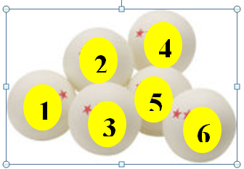

For the purposes of this game make your lucky numbers 1, 2 and 3.

1. List out all 20 ways of getting three numbers. It has been started for you.

|  |  |  |  |  |  |  |  |  |  |
| --- | --- | --- | --- | --- | --- | --- | --- | --- | --- |
| **1,2,3** | **1,2,4** | **1,2,5** |  |  |  |  |  |  |  |
|  |  |  |  |  |  |  |  |  |  |

1. Find the chances of winning each prize.

Gambling always has an “edge” for the company otherwise the company will go broke.

1. Explain why the total sample space is .
2. Explain why the chance of Matching 3 is 
3. Explain why the chance of Matching 2 is 
4. Use a probability distribution table to determine the expected loss for the player for each game.

|  |  |  |  |  |
| --- | --- | --- | --- | --- |
| Outcome | Match 3 | Match 2 | Lose |  |
| $ Result x |  |  |  |  |
| Probability p(x) |  |  |  | Total |
| x.p(x) |  |  |  |  |

**LUCKY TEN.**

***You pay $5 to play.***

***Numbers 1 to 10 are placed in a barrel.***

***You choose 3 numbers beforehand.***

***Three of the 10 numbers are drawn out of the barrel. These are called the Lucky numbers.***

***If your 3 numbers match with the 3 drawn out your payout is $300***

***If two of your lucky numbers match with 2 of the numbers drawn out your payout is $10.***

1. Show working to prove that the player will expect to

lose $0.75 for each game played in Lucky Ten.

Use combinations to help!

### The Roulette Wheel

According to [Richard Epstein](JavaScript:openReference('Epstein')), roulette is the oldest casino game still in operation. It's invention has been variously attributed to [Blaise Pascal](JavaScript:openBiography('Pascal')), the Italian mathematician Don Pasquale, and several others. In any event, the roulette wheel was first introduced into Paris in 1765. Here are the characteristics of the wheel:

The (American) roulette wheel has 38 slots numbered 00, 0, and 1–36.

1. Slots 0, 00 are green;
2. Slots 1, 3, 5, 7, 9, 12, 14, 16, 18, 19, 21, 23, 25, 27, 30, 32, 34, 36 are red;
3. Slots 2, 4, 6, 8, 10, 11, 13, 15, 17, 20, 22, 24, 26, 28, 29, 31, 33, 35 are black.

Except for 0 and 00, the slots on the wheel alternate between red and black. The strange order of the numbers on the wheel is intended so that high and low numbers, as well as odd and even numbers, tend to alternate.

A typical American roulette wheel and table 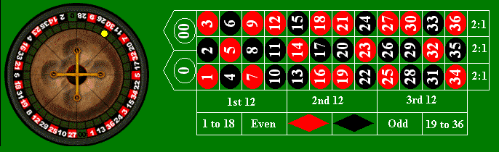

The roulette [experiment](http://www.math.uah.edu/stat/prob/Experiments.html) is very simple. The wheel is spun and then a small ball is rolled in a groove, in the opposite direction as the motion of the wheel. Eventually the ball falls into one of the slots. Naturally, we assume mathematically that the wheel is fair, so that the [random variable](http://www.math.uah.edu/stat/prob/Probability.html) *X*

There are many ways to bet on Roulette. Assume it costs $1 to play each time.

1. Single number bet: match the number get $36 back i.e win $35. Calculate the expected loss or gain for a player.
2. Three number bet; bet on a vertical row of 3 numbers. Pays out $12 if you win. Calculate expectation.

A French Roulette wheel only has 37 numbers, it only has one zero, not two like the American Casinos.

1. Calculate the expected loss or gain for playing a single bet number game for $1 on a French roulette wheel.
2. Comment on which country’s casino is likely to make the most money; the American or French. Justify your answer.

18. The Game of Craps!

Craps is an American gambling game based on throwing two dice and adding the result.

One bet you can make in craps is a “Field bet” which pays $2 if a total of 3,4,9,10 or 11 comes up and $3 if a total of 2 or 12 comes up. All other numbers pay nothing and the game costs $1 to play.

Prove the game loses the gambler more than 5 cents a game! Show all working.

Summarise what you now know about:

1. Standard deviation and Variance.
2. The Binomial probability distribution.
3. Expectation.

|  |
| --- |
| **Strange Definitions** |
| |  |  | | --- | --- | | Aardvark  A vark that thinks it's tough ! | Afford A very popular make of car | | Abdomen Men with beer bellies ! | Angler Someone who is good at maths | | Abigail Strong wind heard in a monastery ! | Alarm Clock Something to scare the living daylight into you | | Absent Minded  Oh ! I seem to have forgotten this one ! | Announce One sixteenth of a pound | | Absolute The best musical instrument in the World, ever ! | Antelope When two ants run off to get married | | Abundance Lots of dancing cakes | Anti-body Uncle's fat wife | | Abyss An abbot's wife | Anti-freeze A female relative from Greenland | | Accidental When you fall and knock your teeth out on the way to the dentist | Apex An old gorilla girlfriend | | Acorn An oak in a nutshell | Appear Something you fish off | | Actor A man who tries to be everything but himself | Apricots Beds for baby monkeys | | Adult A person who has stopped growing at both ends and has started growing in the middle | Archaeologist A person who's career lies in ruins | | Advertising Makes you think you've always wanted something that you've never heard of before | Area Code A cold that hits one part of the country at a time | |

**ABDICATE:**  To give up all hope of ever having a flat stomach.

**ACCOUNT:**  A Countess's husband.

**ACRE:** Literally means the amount of land plowable in one day.  So in my case it would be four feet by four feet.

**ADULT:** A person who has stopped growing at both ends and is now growing in the middle.

**AMNESIA:** condition that enables a woman who has gone through labor to have more babies.

**ANTIQUE:** An item your grandparents bought, your parents got rid of,  and you're buying again.

**ARBITRATOR** (ar'-bi-tray'-ter):  A cook that leaves Arby's to work at Burger King.

**ATHEISM** is a non-prophet organization. -- George Carlin

**AVOIDABLE** (uh-voy'-duh-buhl'):  What a bullfighter tries to do.

**BALDERDASH:**  A rapidly receding hairline.

**BARIUM:**  What we do to most people when they die.

**BATHROOM**: A room used by the entire family, believed by all except Mom to be self-cleaning.

**BEAUTY PARLOR:** Places where women curl up and dye.

**BOSS:**  Someone who is early when you are late and late when you are early.

**CANNIBAL:** Someone who is fed up with people.

**CANTALOUPE:**  Gotta get married in a church.

**CAR SICKNESS:**  The feeling you get when the car payment is due.

**CATALOGS:**  Rails used to build cow fences.

**CHICKENS:** The only animals you eat before they are born and after they are dead.

**CLASSIC:**  A book which people praise, but do not read.

**CLOTHES DRYER:**  An appliance designed to eat socks.

**COFFEE:**  A person who is coughed upon.

**COLLEGE:**  The four year period when parents are permitted access to the telephone.

**COMMITTEE:** A body that keeps minutes and wastes hours.

**COMPROMISE:** The art of dividing a cake in such a way that everybody believes he got the biggest piece.

**CONFERENCE:** The confusion of one man multiplied by the number present.

**CONTROL** (kon'-trol):  A short, ugly inmate.

**COURTESY:**  The art of yawning with your mouth closed.

**DERANGE:** Where de buffalo roam.

**DICTIONARY:** A place where success comes before work.

**DIPLOMAT:** A person who tells you to go to hell in such a way that you actually look forward to the trip.

**DIVORCE:**  Future tense of marriage.

**DOCTOR:**  A person who kills your ills by pills, and kills you with his bills.

**DUMBWAITER**: One who asks if the kids would care to order dessert.

**DUST:** Mud with the juice squeezed out.

**EGOTIST:** Someone who is usually me-deep in conversation.

**EMERGENCY NUMBERS:**  Police station, Fire Department and Places that deliver.

**Etc:**  A sign to make others believe that you know more than you actually do.\

**ETERNITY:** The last two minutes of a football game.

**EYEDROPPER** (i'-drop-ur):  A clumsy ophthalmologist.

**EXPERIENCE :** The name men give to their mistakes.

**FABLE:**  A story told by a teenager arriving home after curfew.

**FAMILY PLANNING:** the art of spacing your children the proper distance apart to keep you on the edge of financial disaster.

**FANCY RESTAURANT:**  One that serves cold soup on purpose.

**FATHER:**  A banker provided by nature.

**FEEDBACK**: The inevitable result when the baby doesn't appreciate the strained carrots.

**FLABBERGASTED:** Appalled over how much weight you have gained.

**FULL NAME:**  What you call your child when you're mad at him/her.

**GOSSIP:** A person who will never tell a lie if the truth will do more damage.

**GRANDMOTHER:** A baby-sitter who doesn't hang around the refrigerator.

**GRANDPARENTS:**  The people who think your children are wonderful even though they're sure you're not raising them right.

**GROCERY LIST:**. What you spend half an hour writing, then forget to take with you to the store.

**GUM**: Adhesive for the hair.

**HAIR DRESSER:**  Someone who is able to create a style you will never be able to duplicate again. See "Magician."

**HANDKERCHIEF:** Cold Storage.

**HEARSAY:**  What toddlers do when anyone mutters a dirty word.

**HEROES** (hee-rhos'):  What a guy in a boat does.

**HINDSIGHT:** What one experiences from changing too many diapers.

**HORS D'OEUVRES:**  A sandwich cut into 20 pieces.

**IMPREGNABLE:**  A woman whose memory of labor is still vivid.

**INDEPENDENT**:  How we want our children to be as long as they do everything we say.

**INFLATION:** Cutting money in half without damaging the paper.

**KISSING:**  A means of getting two people so close together that they can't see anything wrong with each other

**MINIMUM:** Minidad’s wife